Sound Board Quick Guide
Channels
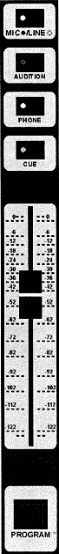
Mic / Line: The light on this button should always be off.
Audition: Pressing this allows you to preview this channel with the Audition button (located under Ctrl. Room. )
Phone: Pressing this allows the person on the phone to hear this channel
Cue: Similar to Audition, pressing this allows you to preview this channel with the Cue button (located under Ctrl. Room.)

Fader: Controls the volume for Program, Audition and Cue

Program: Puts the channel on the air.

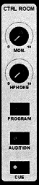 | Ctrl. Room Monitors  Mon: Volume for the in studio monitors (speakers)  HPhone: Master volume for the headphones  Program: Allows you to hear what is on the air  Audition: Allows you to preview in studio all channels that have Audition turned on.  Cue: Allows you to preview in studio all channels that have Cue turned on. | 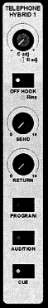 | Phone  Off Hook: Answers the phone  Ring: Lights up and buzzes when there is an incoming call  Send: Controls the volume that the caller hears (note: the caller will only hear channels with phone turned on)  Return: Controls the volume that the listener hears.  Program: Puts the caller on air  Audition: Allows you to screen the caller on the Audition channel (this will not put them on the air)  Cue: Allows you to screen the caller on the Cue channel (this will not put them on the air)

